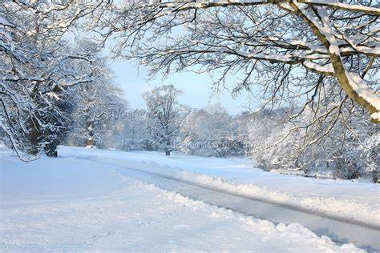

Reception adverse weather days

* In Reception we talk about seasonal changes as part of Understanding the World.
* Take this opportunity to allow your child to explore the snow and ice. Try holding it in their hands and watch it melt. Look at the snowflakes. Discuss the clothing we need to wear on a snowy day. Why do we need to wear certain types of clothing.

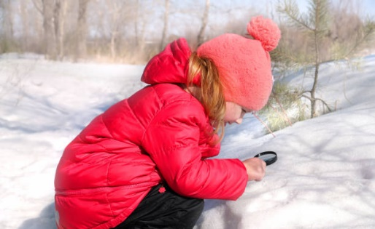

* Make snow sculptures – eg a snow man. Discuss pressing the snow tightly to make shapes.
* Make hot chocolate!
* Watch the story following the link below:

<https://www.youtube.com/watch?v=6mB_6xr2enU>

Discuss the story. What was your child’s favourite part?

* Make a snowy picture or model. Use paints, cotton wool, collage materials.

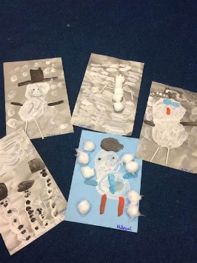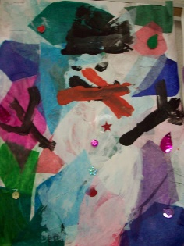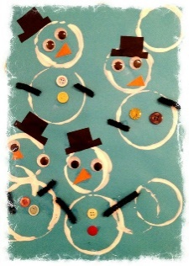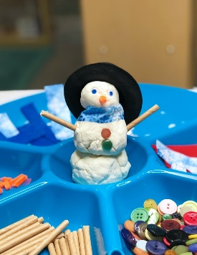

* Practise writing your name.
* Do some counting. Can you find ways of making 2,3,4 and 5 with 2 different amounts

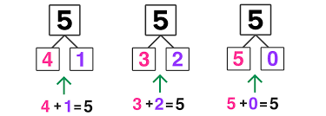

* Go on a shape hunt around the house.